(WP swings)
Woocommerce smart refunder (Storeapps)
Flexible refund and return order for woocommerce ( WP desk)
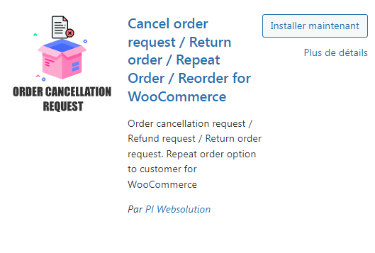
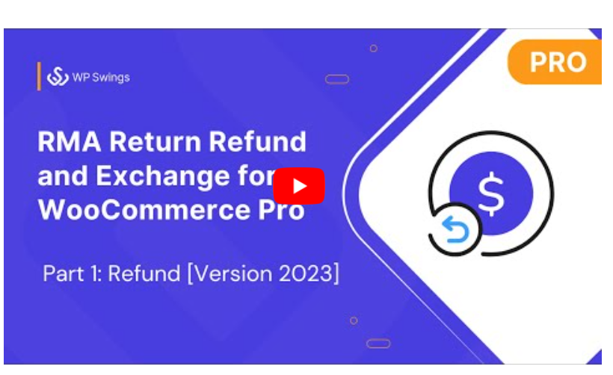
https://docs.wpswings.com/rma-return-refund-exchange-for-woocommerce-pro?utm_source=wpswings-rma-doc&utm_medium=rma-demo-page&utm_campaign=view-doc

https://www.youtube.com/watch?v=z0kG75E60TI

